End Drawer with required fields

Workshop #4

Flutter Developer Bootcamp

# **Purpose**

This workshop demonstrates how to create End Drawer with with required fields.

# **Problem**

In the given workshop, there are 6 categories of cat with their name, price and like button icon and filter icon and search icon on the app bar. (Bella **₹** 5000, Lucy **₹**1000, Loki **₹**2000, Milo **₹**10000, Leo **₹**6500, Oggy **₹**3500). You need to create EndDrawer with breed category, age limit, published date, checkbox which shows looking to adopt, price range, location, checkbox of Whether the pet is vaccinated or not, certified or not and add a button name apply.

# **How to Solve**

1. Checkout the workshop from Git Repo:

git clone -b <user-branch> <repo-URL>

2. Open the root folder inside VS Code

3. Execute the code by running command from the root: <full-command>

4. The EndDrawer should include filtering by breed category, age, published date, with checkboxes for looking to adopt, pet vaccination status, and certification, along with price range, location selection, and an "Apply" button to confirm filters.

5. Go To File: <specific-file-with-end drawer-method> à <method-name>, implement your widget creation logic.

**You will Achieve**

When you complete this workshop you will learn the following:

* **ListView**: Implementing scrollable lists of items.
* **End Drawer**: Adding an end drawer for additional navigation or settings options.
* **Dropdowns**: Incorporating dropdown menus for selecting options from a list.
* **Checkboxes**: Adding checkboxes for allowing users to make multiple selections.
* **App Bars**: Utilizing app bars for navigation, actions, and branding.
* **Text Fields**: Integrating text fields for user input of text or data.
* **Buttons**: Incorporating buttons for triggering actions or navigation within the app.
* **Circle Avatars**: Displaying circular profile images or placeholders.
* **Icons**: Utilizing icons for visual representation and interaction.
* **Padding**: Adjusting spacing around widgets to improve layout aesthetics.
* **SizedBoxes**: Managing widget sizes and spacing within your app's layout.
* **Text**: Displaying text content within your app.
* **Adjusting text alignment**: Controlling the alignment of text elements to enhance readability and design consistency.

# **Screenshots**

## **Before implementation (without End Drawer)**

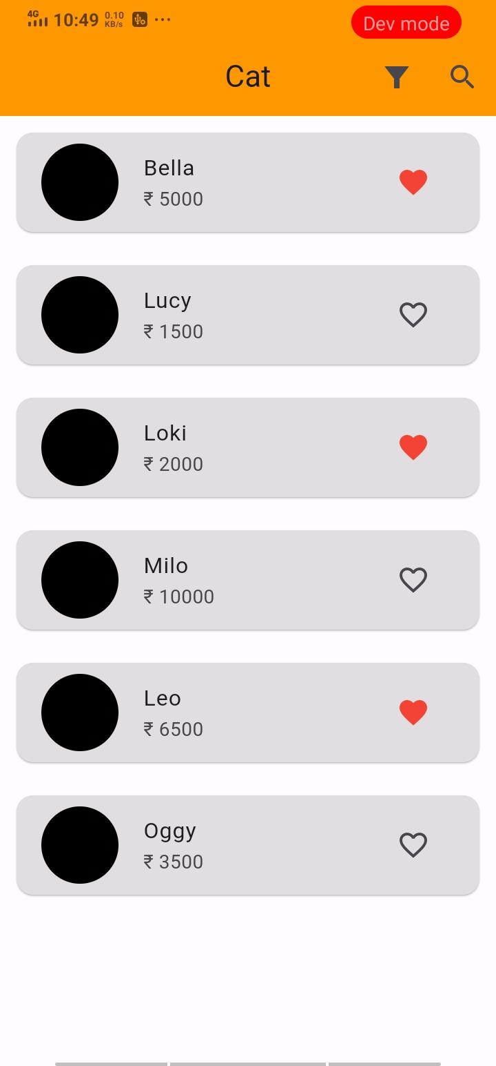

## **After implementation (With End Drawer)**

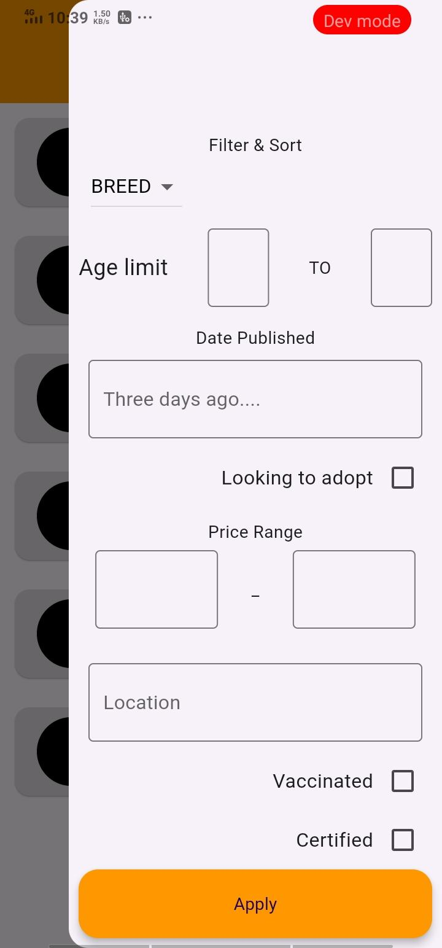

# **How to submit your workshop**

Push your project back to the same git branch using command:

<command name>

# **Happy Coding!**